Indian Weather Repository

Submitted in partial fulfillment of completion of the course

Advanced Diploma in IT, Networking and Cloud Computing

Submitted by:

**Aashika Raj**

Under Guidance of:

**Arpita Roy (Edu net)**

  

Year 2023

**PROJECT OVERVIEW**

Project Overview

Acknowledgement

Table of Contents

1. Introduction to Problem
2. Proposed Solution
3. Requirements

4.1 Technology Stack

4.2 Hardware

4.3 Software

4.4 Deployment Environment

5. User Requirements

6. Design Documentation

7. Implementation Details

8. Testing

9. Deployment

10. Conclusion

Appendix A Screenshot of Project

References

**Project Overview**: Indian Weather Repository

Objective:

The Indian Weather Repository project aims to develop a comprehensive and centralized platform for managing, analyzing, and disseminating weather-related data and forecasts across India. The repository seeks to address the existing challenges in weather information management and enhance accessibility for various stakeholders.

Country

Location name

Region

Latitude

Longitude

Time zone

Temperature C

Temperature F

Wind degree

Pressure

Humidity

Clouds

Visibility km

Visibility miles

Air quality

Sunrise

Sunset

Moonrise

Moonset

Moon phase

**Questions:**

* Analyze the historical weather data to identify long-term patterns and trends.
* Explore geographical variations in weather conditions across different regions.
* Investigate relationships between various weather parameters and their effects on each other
* Study the impact of weather conditions on air quality measurements.
* Examine correlations between celestial events and weather phenomena.

Key Components:

1. Data Integration:

- Objective: Aggregate weather data from diverse sources, including government agencies, private forecasters, and international organizations.

- Implementation: Develop protocols and APIs for seamless data integration, ensuring a standardized format for consistency.

2. User-Friendly Interface:

- Objective: Enhance accessibility for a wide range of users, including rural communities, farmers, government officials, and researchers.

- Implementation: Design an intuitive and user-friendly interface with interactive maps, visualizations, and customizable features.

3. Real-time Forecasting:

- Objective: Provide timely and accurate weather forecasts to support disaster preparedness, agriculture, and various industries.

- Implementation: Implement advanced modeling techniques and leverage emerging technologies such as artificial intelligence for real-time forecasting.

4. Historical Data Management:

- Objective: Establish a centralized archive for historical weather data to support long-term trend analysis, climate research, and policymaking.

- Implementation: Develop a robust system for storing, retrieving, and analyzing historical weather data with efficient indexing and search capabilities.

5. Public Awareness and Education:

- Objective: Increase public awareness and understanding of weather forecasts to facilitate informed decision-making during adverse conditions.

- Implementation: Integrate educational resources, alerts, and notifications to enhance public engagement and awareness.

6. Standardized Data Formats:

- Objective: Address interoperability challenges by adopting standardized data formats for seamless data exchange and collaboration.

- Implementation: Define and adhere to industry-standard data formats and protocols to ensure compatibility with various systems.

7. Adaptability to Emerging Technologies:

- Objective: Stay at the forefront of technological advancements by integrating emerging technologies like machine learning for improved prediction accuracy.

- Implementation: Design the repository architecture to be adaptable to future technological innovations, with regular updates and improvements.

**REQUIREMENTS**

**HARDWARE**

* Server: A dedicated server or cloud-based virtual machine (VM) to host jupyter notebook
* CPU and RAM
* Storage: Adequate storage space for the csv file, application code, and uploaded files.
* Network Infrastructure: Reliable internet connectivity, firewalls, and security measures to protect the system.

**SOFTWARE**

* Operating System
* Python with Pandas, NumPy, and Scikit-Learn, along with any necessary packages and dependencies. Use virtual environments to manage Python dependencies.
* Development Tools: jupyter notebook
* Version Control Tools: GitHub or GitLab
* Web Server

**DEPLOYMENT ENVIRONMENT**

* The size and complexity of the project
* The security requirements of the project
* The budget for the project
* The technical expertise of the team

**USER REQUIREMENTS**

* Mobile Accessibility or PCs
* Internet Access
* Supported Browser
* Agreement to Terms

Benefits:

1. Improved Decision-Making:

- Stakeholders across sectors can make informed decisions based on accurate and timely weather information.

2. Enhanced Public Safety:

- Public awareness, coupled with timely alerts and notifications, contributes to improved safety during adverse weather events.

3. Optimized Agriculture Practices:

- Farmers can optimize agricultural activities based on precise weather forecasts, leading to increased productivity.

4. Infrastructure Planning:

- Construction and maintenance activities can be planned more efficiently, reducing the impact of weather-related disruptions.

5. Research and Education:

- Researchers and educational institutions can access a rich repository of weather data for climate studies and educational purposes.

Project Timeline:

The project will be executed in phases, with key milestones including data integration, interface development, real-time forecasting implementation, historical data management, and ongoing improvements. Regular updates and feedback loops will ensure continuous enhancement of the repository.

By addressing these aspects, the Indian Weather Repository project seeks to revolutionize the accessibility and utilization of weather data in India, contributing to the overall well-being and resilience of the nation.

**Why do we need this?**

The need for an Indian Weather Repository arises from various factors and challenges associated with weather data management, dissemination, and utilization in India. Here are several reasons why such a repository is essential:

1. Diverse Climate and Geography:

- India has a diverse climate and geography, ranging from mountains to plains and deserts to coastal regions. The varied weather patterns necessitate a centralized repository to consolidate data from different regions for comprehensive analysis and forecasting.

2. Disaster Preparedness:

- Accurate and timely weather information is crucial for disaster preparedness. A repository facilitates real-time monitoring and forecasting of events such as cyclones, floods, and droughts, enabling authorities to take proactive measures.

3. Agricultural Planning:

- Agriculture, a significant part of India's economy, heavily depends on weather conditions. A repository aids farmers in planning planting and harvesting cycles, optimizing irrigation, and mitigating the impact of extreme weather events on crops.

4. Infrastructure Development:

- Construction and maintenance of infrastructure are influenced by weather conditions. A centralized repository assists in planning construction schedules, maintenance activities, and disaster-resistant infrastructure development.

5. Public Safety and Awareness:

- Providing accurate and accessible weather information enhances public safety. A repository ensures that individuals and communities are informed about potential hazards, allowing them to take necessary precautions during adverse weather conditions.

6. Transportation and Logistics:

- Weather conditions significantly impact transportation systems. A centralized repository aids in planning air, land, and sea transport operations, reducing disruptions and improving overall efficiency.

7. Energy Sector Management:

- The energy sector, including power generation and distribution, is affected by weather patterns. Accurate weather forecasts assist in managing energy resources effectively, especially in the case of renewable energy sources.

8. Research and Climate Studies:

- Researchers and climate scientists require comprehensive and historical weather data for studies related to climate change, long-term trends, and environmental impact. A repository serves as a valuable resource for such research.

9. Government Policy Formulation:

- Weather data plays a vital role in the formulation of government policies related to agriculture, disaster management, urban planning, and environmental conservation. A repository supports evidence-based policymaking.

10. Improved Decision-Making Across Sectors:

- Businesses, industries, and various sectors require accurate weather forecasts for decision-making. A centralized repository ensures that stakeholders have access to reliable information for planning and operational purposes.

11. Open Data Initiatives:

- An open and accessible repository supports open data initiatives, promoting transparency and allowing developers, researchers, and the public to use weather data for innovative applications and analyses.

In summary, an Indian Weather Repository is crucial for addressing the diverse and dynamic weather conditions in the country. It supports various sectors, enhances public safety, and contributes to informed decision-making at individual, community, and governmental levels.

**How will it help people?**

The Indian Weather Repository can significantly benefit people in various ways by providing accurate and timely weather information. Here are several ways in which the repository can help individuals, communities, and various sectors:

1. Disaster Preparedness:

- Early warning systems based on accurate weather forecasts help people prepare for and respond to natural disasters such as cyclones, floods, and storms. This leads to improved evacuation planning and reduces the impact of disasters on communities.

2. Agriculture Planning:

- Farmers can use weather information to plan their agricultural activities effectively. This includes deciding the optimal planting and harvesting times, irrigation scheduling, and selecting appropriate crops based on weather conditions.

3. Public Safety:

- Individuals and communities receive timely alerts and notifications about extreme weather events, enabling them to take necessary precautions for personal safety. This is crucial during events like heavy rainfall, heatwaves, or cold spells.

4. Infrastructure Management:

- Construction and maintenance of infrastructure are influenced by weather conditions. The repository helps in planning these activities more efficiently, reducing disruptions and improving the overall resilience of infrastructure.

5. Transportation Efficiency:

- Accurate weather forecasts aid in planning transportation routes and schedules. This is especially important for air, land, and sea transport, helping to minimize disruptions and ensure the safety of travelers.

6. Energy Resource Management:

- The energy sector, including power generation from renewable sources, relies on weather conditions. The repository assists in managing energy resources efficiently, ensuring a stable and reliable energy supply.

7. Tourism and Outdoor Activities:

- Tourists and individuals planning outdoor activities can make informed decisions based on weather forecasts. This enhances safety and the overall experience of travelers and adventure enthusiasts.

8. Health Precautions:

- Weather information, especially during extreme conditions, can provide valuable health-related guidance. For example, during heatwaves or periods of poor air quality, people can take necessary precautions to protect their health.

9. Educational Resources:

- The repository can include educational resources and information to enhance public awareness about weather patterns, climate change, and environmental issues. This contributes to a more informed and environmentally conscious society.

10. Smart Agriculture Practices:

- Farmers can adopt smart agriculture practices based on weather data, optimizing resource use, reducing environmental impact, and improving overall agricultural productivity.

11. Community Empowerment:

- By providing easy access to weather information, the repository empowers communities to take proactive measures for their well-being. This includes making informed decisions related to daily activities, land use, and resource management.

12. Scientific Research:

- Researchers and scientists benefit from the repository's historical data and advanced forecasting capabilities for climate studies, environmental research, and scientific exploration.

In summary, the Indian Weather Repository plays a crucial role in enhancing the quality of life, safety, and productivity of individuals and communities by providing them with accurate and accessible weather information for various applications and decision-making processes.

**Solution**

Creating an effective solution for an Indian Weather Repository involves a combination of technological infrastructure, data management practices, and user-centric features. Here is a high-level overview of the potential solution:

1. Data Integration:

- Objective: Aggregate weather data from diverse sources, including government agencies, private forecasters, and international organizations.

- Implementation: Develop robust protocols and APIs for seamless integration, ensuring a standardized format for consistency.

2. User-Friendly Interface:

- Objective: Enhance accessibility for a wide range of users, including rural communities, farmers, government officials, and researchers.

- Implementation: Design an intuitive and user-friendly web and mobile interface with interactive maps, visualizations, and customizable features. Implement multi-language support for wider accessibility.

3. Real-time Forecasting:

- Objective: Provide timely and accurate weather forecasts to support disaster preparedness, agriculture, and various industries.

- Implementation: Implement advanced modeling techniques, leveraging meteorological data and incorporating machine learning for real-time forecasting. Regularly update algorithms for improved accuracy.

4. Historical Data Management:

- Objective: Establish a centralized archive for historical weather data to support long-term trend analysis, climate research, and policymaking.

- Implementation: Develop a robust data storage and retrieval system with efficient indexing. Enable users to access historical weather data through a user-friendly interface.

5. Public Awareness and Education:

- Objective: Increase public awareness and understanding of weather forecasts to facilitate informed decision-making during adverse conditions.

- Implementation: Integrate educational resources, alerts, and notifications into the platform. Develop educational modules on weather-related topics. Collaborate with media outlets for broader dissemination.

6. Standardized Data Formats:

- Objective: Address interoperability challenges by adopting standardized data formats for seamless data exchange and collaboration.

- Implementation: Define and adhere to industry-standard data formats and protocols. Collaborate with relevant international standards organizations to ensure compatibility.

7. Adaptability to Emerging Technologies:

- Objective: Stay at the forefront of technological advancements by integrating emerging technologies like machine learning for improved prediction accuracy.

- Implementation: Design the repository architecture to be adaptable to future technological innovations. Collaborate with research institutions and technology companies for ongoing updates and improvements.

8. Accessibility:

- Objective: Ensure accessibility to a wide range of users, including those in remote areas with limited connectivity.

- Implementation: Optimize the platform for low-bandwidth situations. Develop a mobile application for easy access. Collaborate with local authorities for community outreach.

9. Security and Privacy:

- Objective: Ensure the security and privacy of sensitive weather data.

- Implementation: Implement robust security protocols, including encryption and access controls. Comply with data protection regulations.

10. Feedback Mechanism:

- Objective: Gather feedback from users for continuous improvement.

- Implementation: Implement a user feedback mechanism within the platform. Regularly analyze feedback to identify areas for enhancement.

11. Collaboration with Stakeholders:

- Objective: Collaborate with government agencies, research institutions, and private entities.

- Implementation: Establish partnerships for data sharing and mutual support. Encourage collaborative research initiatives.

12. Scalability:

- Objective: Ensure the platform can handle increasing data volumes and user traffic.

- Implementation: Design scalable architecture using cloud infrastructure. Regularly monitor and optimize performance.

By addressing these aspects, the Indian Weather Repository solution can provide a reliable, accessible, and technologically advanced platform for managing and utilizing weather data across the diverse landscapes of India. Regular updates, collaboration, and feedback mechanisms are essential for its ongoing success.

**TESTING**

**SCREENSHOT OF PROJECT**

**This is the overall how to create project image**

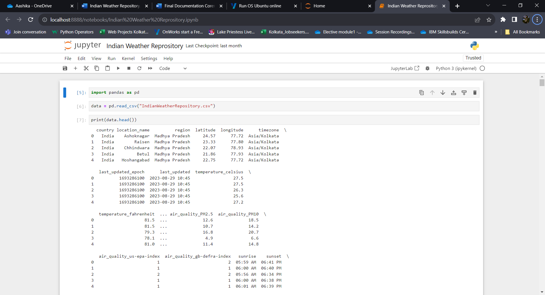

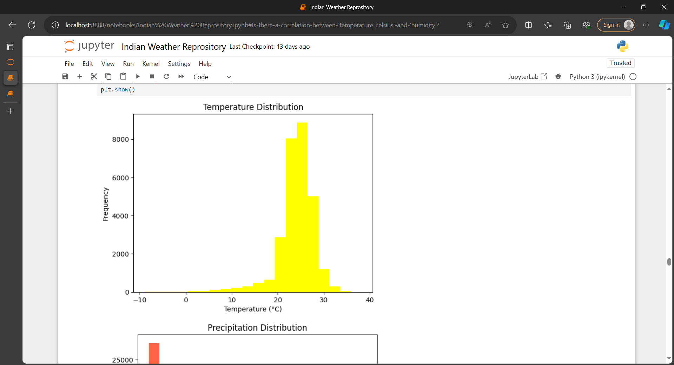

**How its unique**

The uniqueness of an Indian Weather Repository lies in its specific focus on the diverse and dynamic weather patterns and conditions of India. Here are several aspects that make it unique:

1. Regional Specificity:

- Tailored for the unique climate zones and geographical features of India, considering the varying weather patterns from the Himalayas to the coastal regions and deserts.

2. Diverse Data Integration:

- Aggregates data from various sources, including government meteorological agencies, private forecasters, and international organizations, to provide a holistic and comprehensive view of weather conditions.

3. Localized Forecasting Models:

- Develops and utilizes forecasting models specifically calibrated for the Indian subcontinent, taking into account the complexities of the monsoon, tropical cyclones, and other region-specific weather phenomena.

4. Agricultural Emphasis:

- Incorporates features and information specifically beneficial for the agriculture sector, addressing the needs of farmers by providing insights into planting and harvesting times, irrigation scheduling, and crop selection.

5. Disaster Preparedness for India:

- Focuses on providing real-time and accurate weather information for disaster preparedness, considering the vulnerability of certain regions to events like floods, cyclones, and droughts.

6. Cultural and Societal Considerations:

- Integrates cultural and societal considerations in the design and communication of weather information, recognizing the importance of weather in festivals, rituals, and daily life.

7. Multi-language Support:

- Incorporates support for multiple languages to ensure accessibility for people across linguistic diversity in India, making weather information more inclusive.

8. Government Collaboration:

- Collaborates closely with the India Meteorological Department (IMD) and other government agencies to ensure the repository aligns with national policies and standards.

9. Public Awareness and Education:

- Implements features specifically designed to enhance public awareness and education regarding weather patterns and safety measures, considering the diverse educational backgrounds of the population.

10. Open Data Initiatives:

- Promotes open data initiatives, allowing developers, researchers, and the public to access and use weather data for innovative applications and analyses that cater to the unique needs of the Indian context.

11. Customizable for Local Authorities:

- Provides tools and features that can be customized for use by local authorities, enabling them to make localized decisions based on accurate weather information.

12. Adaptability to Local Technologies:

- Adapts to local technologies and infrastructure constraints, ensuring that the repository is accessible even in areas with limited connectivity or technology resources.

In essence, the uniqueness of an Indian Weather Repository lies in its ability to cater specifically to the challenges and opportunities presented by India's diverse climate, geography, and societal dynamics, making it a valuable and tailored resource for the nation.

**Modelling (Analysis Model) And Visualization**

Developing an analysis model and visualization components for an Indian Weather Repository involves a combination of data processing algorithms, statistical models, and user-friendly visualizations. Below is a high-level overview of the analysis model and visualization components:

Analysis Model:

1. Data Processing:

- Objective: Clean, preprocess, and standardize weather data from various sources.

- Implementation: Develop algorithms to handle missing data, outliers, and inconsistencies. Ensure standardized units and formats for different types of weather parameters.

2. Real-time Forecasting:

- Objective: Implement models for accurate and timely weather forecasting.

- Implementation: Utilize advanced meteorological models, machine learning algorithms, and historical data to predict weather conditions in real-time. Regularly update models based on new data.

3. Historical Data Analysis:

- Objective: Analyze historical weather data for long-term trends and patterns.

- Implementation: Develop algorithms to extract meaningful insights from historical data, such as temperature trends, rainfall patterns, and frequency of extreme events.

4. Agricultural Insights:

- Objective: Provide insights for agricultural planning.

- Implementation: Develop models that correlate weather patterns with optimal planting and harvesting times, irrigation requirements, and crop suitability. Provide recommendations for farmers based on current and forecasted weather conditions.

5. Disaster Risk Assessment:

- Objective: Assess the risk of weather-related disasters.

- Implementation: Implement models that evaluate the risk of events like cyclones, floods, and droughts based on historical data and real-time conditions. Provide risk maps and early warnings.

6. Spatial Analysis:

- Objective: Analyze spatial variations in weather patterns.

- Implementation: Develop spatial analysis algorithms to identify variations in temperature, precipitation, and other parameters across different regions. Create visualizations for spatial trends.

Visualization Components:

1. Interactive Dashboards:

- Objective: Provide a user-friendly interface for accessing and visualizing weather data.

- Implementation: Develop interactive dashboards that allow users to customize and explore weather data. Include features like map overlays, time-series charts, and region-specific views.

2. Weather Maps:

- Objective: Visualize real-time and historical weather patterns on maps.

- Implementation: Use GIS (Geographic Information System) tools to create interactive weather maps. Include layers for temperature, precipitation, wind speed, and other relevant parameters.

3. Time-Series Charts:

- Objective: Show temporal trends and patterns.

- Implementation: Develop time-series charts for temperature, rainfall, and other weather parameters. Allow users to zoom in on specific time periods and compare historical data with real-time observations.

4. Predictive Analytics:

- Objective: Visualize forecasted weather conditions.

- Implementation: Display predictive analytics through charts and graphs, indicating future weather trends. Include confidence intervals and probability distributions to communicate forecast uncertainty.

5. Agricultural Planning Tools:

- Objective: Provide farmers with visual tools for planning agricultural activities.

- Implementation: Develop visualizations that guide farmers in decision-making, such as heat maps for optimal planting times, charts for rainfall predictions, and irrigation planning tools.

6. Disaster Risk Maps:

- Objective: Communicate the risk of weather-related disasters.

- Implementation: Create risk maps that highlight areas prone to disasters based on historical data and real-time conditions. Include layers for flood risk, cyclone paths, and other relevant information.

7. Public Awareness Campaigns:

- Objective: Increase public awareness through visualizations.

- Implementation: Design visual campaigns using infographics and animations to communicate weather-related information to the general public. Include safety guidelines and emergency procedures.

8. Customizable Alerts and Notifications:

- Objective: Enable users to receive personalized alerts.

- Implementation: Develop a notification system that allows users to set preferences for weather alerts based on their location, interests, and specific parameters (e.g., rain, temperature).

9. Educational Visuals:

- Objective: Enhance public understanding of weather phenomena.

- Implementation: Create educational visualizations, including animations and interactive features, to explain complex weather phenomena, climate change concepts, and the impact of weather on daily life.

By integrating these analysis models and visualization components, the Indian Weather Repository can offer a powerful and user-friendly platform for understanding, analyzing, and leveraging weather data for various purposes. Regular updates and user feedback mechanisms are essential for continuous improvement.

**Live Demo-Analysis Dashboard**

I don't have the ability to provide live demos, but I can suggest the elements and features that could be part of an analysis dashboard for an Indian Weather Repository. If you're working on developing such a dashboard, you may consider integrating the following components:

1. Real-Time Weather Overview:

- Display current weather conditions across different regions of India.

- Include temperature, humidity, wind speed, and other key parameters.

2. Interactive Map:

- Utilize a map interface to allow users to visualize weather patterns geographically.

- Implement overlays for precipitation, temperature gradients, and other relevant data.

3. Time-Series Charts:

- Show historical and forecasted trends for key weather parameters.

- Enable users to zoom in on specific time periods for detailed analysis.

4. Agricultural Planning Tools:

- Provide farmers with tools for optimizing agricultural activities.

- Include planting and harvesting calendars, rainfall predictions, and irrigation planning.

5. Disaster Risk Assessment:

- Visualize areas at risk of weather-related disasters such as floods, cyclones, or droughts.

- Include risk scores, historical data, and early warning alerts.

6. Customizable Alerts:

- Allow users to set up personalized weather alerts for their specific locations and parameters of interest.

7. Educational Visuals:

- Integrate educational elements explaining weather phenomena, climate change, and the impact on daily life.

- Include interactive infographics and animations.

8. Public Awareness Section:

- Highlight safety guidelines, emergency procedures, and tips for different weather conditions.

- Use visual content to convey important information to the general public.

9. Predictive Analytics:

- Include predictive models for future weather conditions.

- Communicate uncertainty and confidence levels in forecasts.

10. Feedback Mechanism:

- Allow users to provide feedback on the accuracy and usefulness of weather information.

- Implement a system for users to report local weather observations.

11. Mobile Responsiveness:

- Ensure the dashboard is mobile-friendly for users accessing it from different devices.

- Optimize the interface for various screen sizes.

12. Data Sources Attribution:

- Clearly indicate the sources of weather data used in the dashboard.

- Provide information on data accuracy, update frequency, and reliability.

Remember that the effectiveness of the dashboard depends on accurate and up-to-date data, user-friendly design, and relevant features that cater to the diverse needs of users, including farmers, researchers, government officials, and the general public. Additionally, collaboration with meteorological agencies and experts in the field can enhance the quality and reliability of the information provided.

**Result (Prediction Model)**

Creating a weather result prediction model involves utilizing various data sources and applying statistical or machine learning techniques to forecast future weather conditions. Below is a simplified outline of the process:

1. Data Collection:

- Collect historical weather data from reliable sources, including temperature, humidity, wind speed, precipitation, and atmospheric pressure.

- Include geographic data and any relevant external factors that might influence weather patterns.

2. Data Cleaning and Preprocessing:

- Handle missing data, outliers, and inconsistencies in the dataset.

- Normalize or scale numerical features to ensure uniformity in the dataset.

- Convert categorical variables into numerical representations if needed.

3. Feature Selection:

- Identify the most relevant features that contribute to weather patterns.

- Consider using domain knowledge and statistical techniques to select the most informative features.

4. Model Selection:

- Choose an appropriate predictive modeling technique. Common approaches include:

- Regression Models: Linear regression, polynomial regression, etc.

- Time Series Models: ARIMA (Auto Regressive Integrated Moving Average), SARIMA (Seasonal ARIMA), etc.

- Machine Learning Models: Random Forest, Gradient Boosting, Neural Networks, etc.

5. Model Training:

- Split the dataset into training and testing sets.

- Train the selected model using the training set.

6. Hyperparameter Tuning:

- Optimize the model's hyperparameters to improve its performance.

- Utilize techniques like grid search or randomized search.

7. Validation:

- Evaluate the model on the testing set to ensure it generalizes well to new, unseen data.

- Use metrics such as Mean Absolute Error (MAE), Mean Squared Error (MSE), or others depending on the nature of the problem.

8. Prediction:

- Once the model is trained and validated, use it to make predictions for future weather conditions.

- Provide uncertainty estimates or confidence intervals for the predictions.

9. Integration with Repository:

- Integrate the prediction model into the Indian Weather Repository platform.

- Ensure seamless communication between the model and the rest of the repository infrastructure.

10. Continuous Monitoring and Updating:

- Regularly monitor the model's performance over time.

- Update the model as new data becomes available to ensure it remains accurate and relevant.

11. User Interface Integration:

- Present the model's predictions through user-friendly interfaces in the analysis dashboard.

- Provide visualizations and alerts based on the model's outputs.

12. Feedback Loop:

- Establish a feedback loop for users to provide input on the accuracy of predictions.

- Use user feedback to continuously improve and refine the prediction model.

It's important to note that the accuracy of weather prediction models is influenced by the complexity of atmospheric processes, and no model can predict with absolute certainty. However, by incorporating advanced techniques and continuous refinement, the model can provide valuable insights for planning and decision-making.